EXPERIMENT – 1

ROLL NO: 240701520 NAME: SOAMESHWARAN D
USER INTERFACE DESIGN
COMPARSION OF UI DESIGN BTW TWO DESIGNS

BAD WEBSITE:
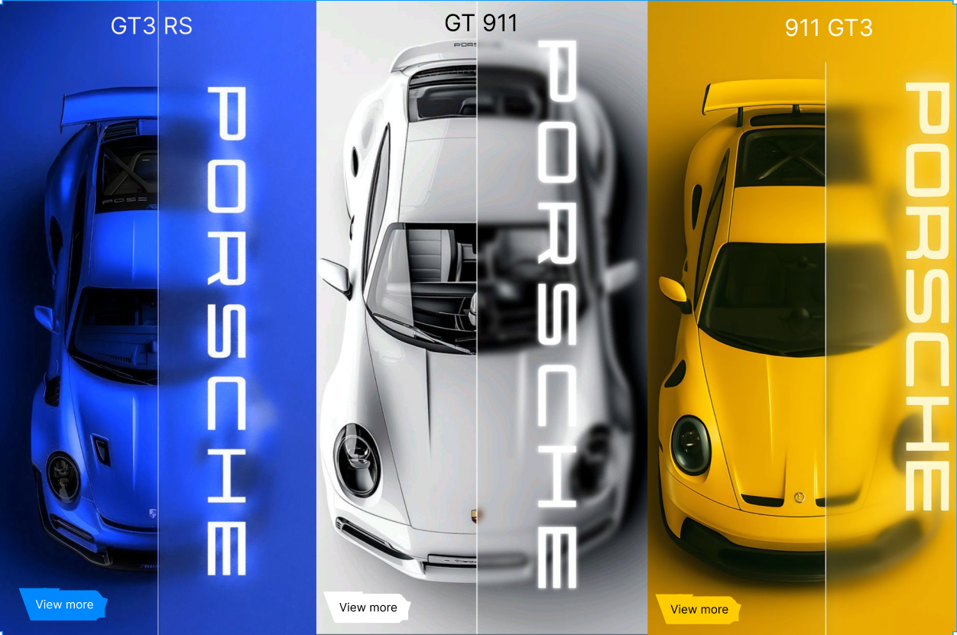
Reasons for Poor Design
- Lack of Visual Hierarchy
The design does not guide the viewer’s eye clearly. Important elements like car models and brand identity compete with each other instead of having a clear priority.
- Overuse of Typography Effects
The vertically stretched “PORSCHE” text is repeated multiple times, making the layout feel cluttered and distracting rather than informative.

GOOD WEBSITE:

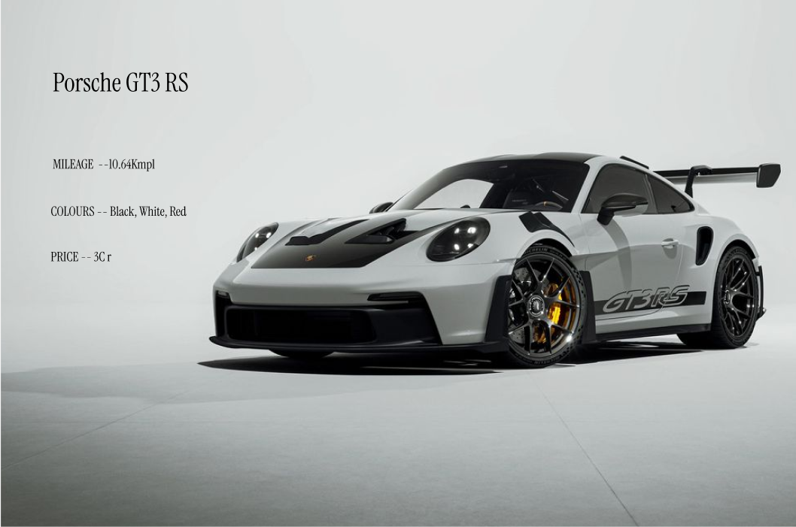
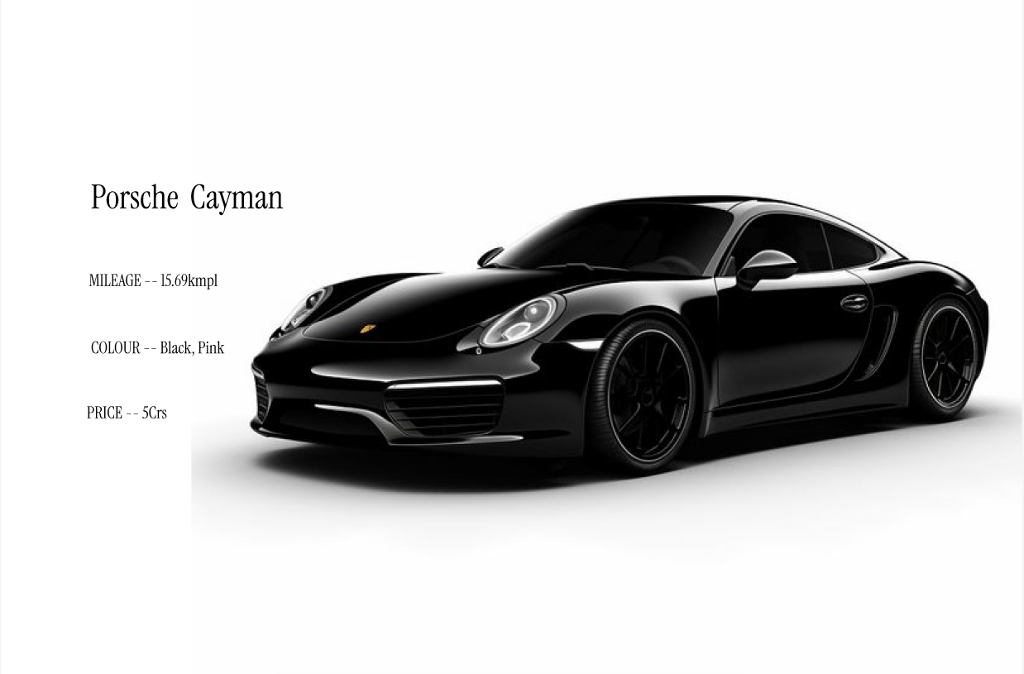
Reasons for Good Design
- Clear Visual Hierarchy
The car image is the primary focus, while the text is neatly placed on the left, guiding the viewer’s eye naturally from information to product.
- Consistent Color Scheme
The black car against a white background provides strong contrast while maintaining elegance and visual harmony.

- Focused User Attention
Only essential information (model, mileage, colour, price) is displayed, preventing distraction and improving user focus.

Key Differences Between the Two Designs
- Layout
- Colour
- Typography

